Q1.

mysql> select Firstname,Lastname,Email

from customers;



Q2.

Select

orders.OrderID,orders.OrderDate,customers.Firstname,

customers.Lastname

from orders

JOIN customers ON orders.CustomerID=customers.CustomerID;

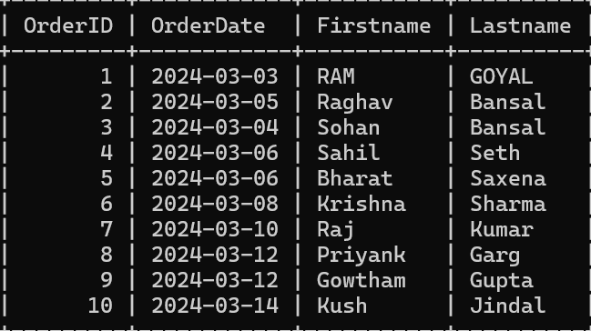

Q3.

mysql> INSERT INTO customers(Firstname,Lastname,Email,Phone,Address)

values('Dev','Nagpal','dev@gmail.com','1423765098','427 Street Chandigarh');

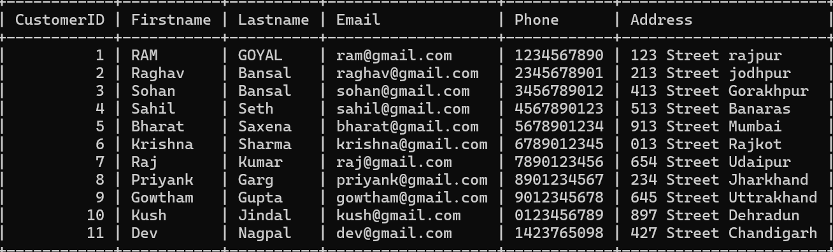

Q4.

mysql> update products

set Price=Price\*1.10;

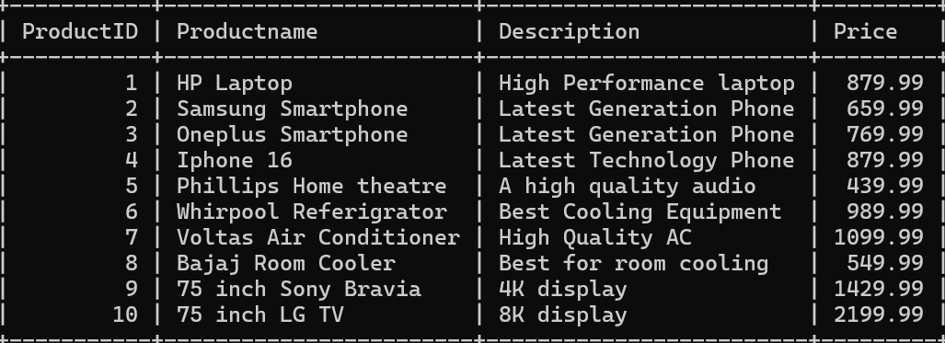

Q5.

mysql> Delete from orderdetails where OrderID=10;

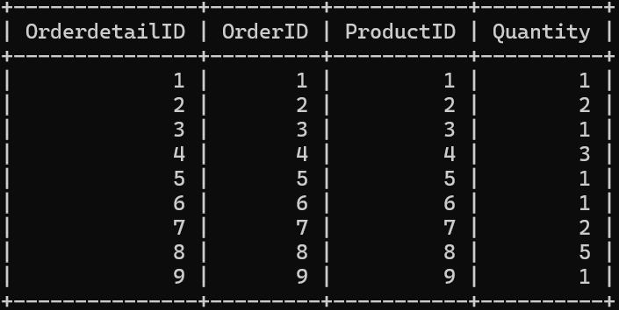

mysql> Delete from orders where OrderID=10;

Query OK, 1 row affected (0.00 sec)

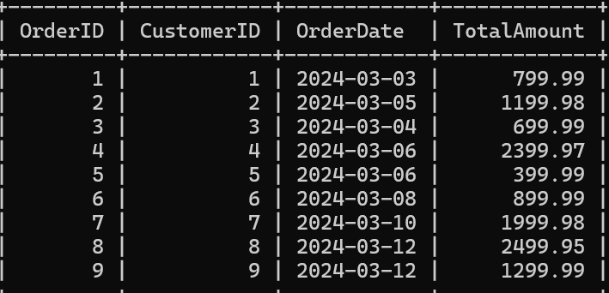

Q6.

mysql> INSERT INTO orders(CustomerID,OrderDate,TotalAmount)

values(10,'2024-03-14',1999.99);

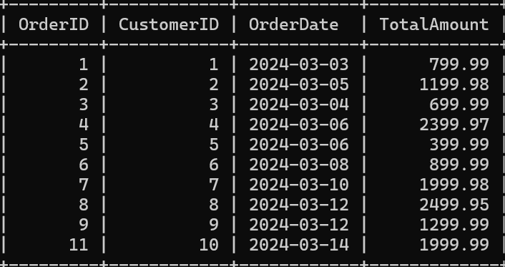

Q7.

mysql> update customers

set Email='dev1@gmail.com',Address='514 Street Chandigarh'

where CustomerID=11;

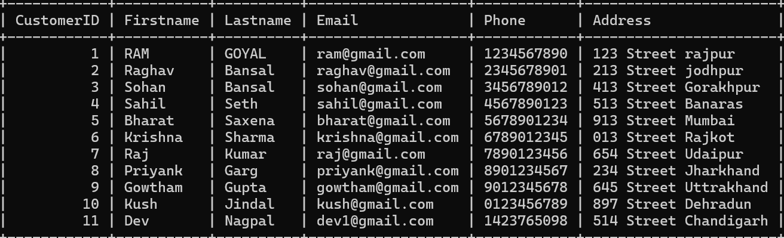

Q8.

mysql> UPDATE orders

SET TotalAmount = (

SELECT SUM(products.Price \* orderdetails.Quantity)

FROM orderdetails

JOIN products ON orderdetails.ProductID = products.ProductID

WHERE orders.OrderID = orderdetails.OrderID );

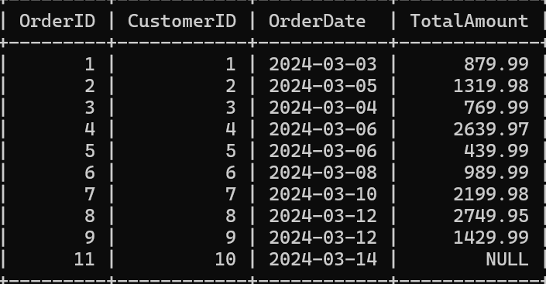

Q9.

mysql> DELETE FROM orderdetails

WHERE OrderID IN (SELECT OrderID

FROM orders WHERE CustomerID = 2);

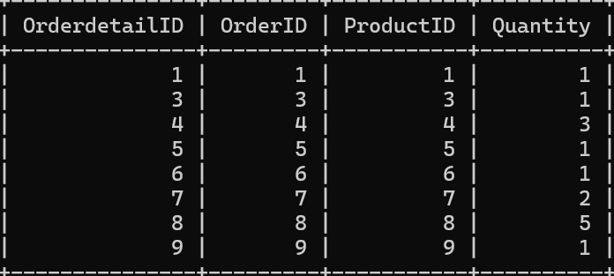

mysql> DELETE FROM Orders WHERE CustomerID = 2;

Q10.

mysql> INSERT INTO products(Productname,Description,Price)

values('Headphone','High Definition Audio',549.99);



Q11.

mysql> Alter Table orders

ADD Status VARCHAR(255);

mysql> update orders

set Status='SHIPPED'

where OrderID=3;

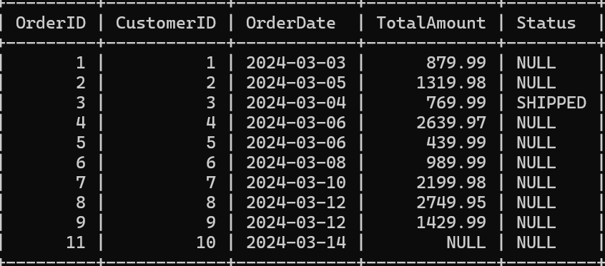

Q12.

mysql> Alter table customers

ADD TotalOrders INT;

mysql> update customers

set TotalOrders=(select count(\*)

from orders

where customers.CustomerID=orders.CustomerID);

